CV of Dr Michael Nazmy Agban
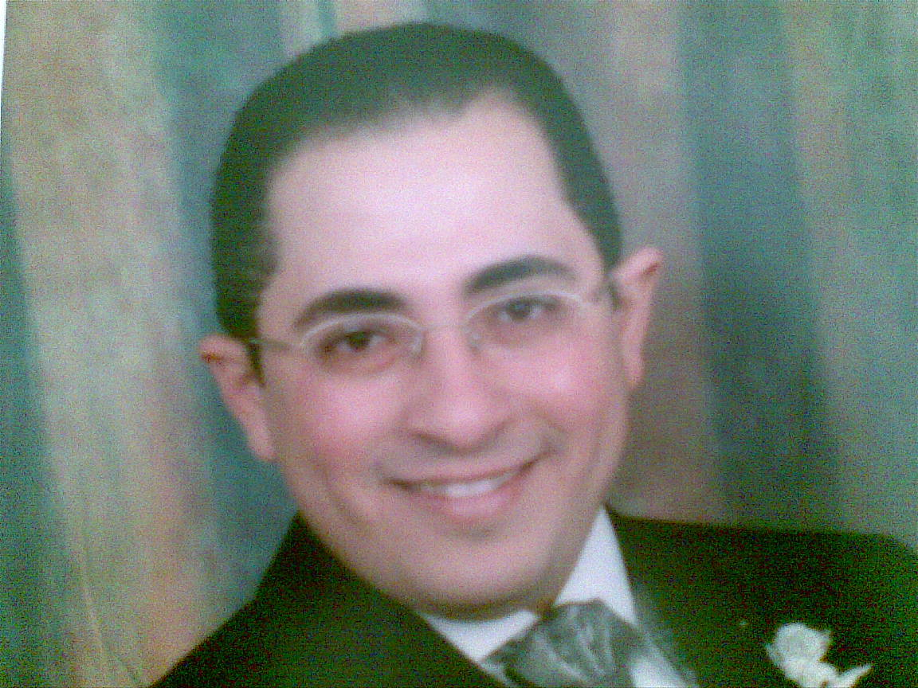
Associated Professor of Microbiology & Immunology
Born in 31/10/1974 in Assiut – Egypt.
Resident in Assiut- Mahmod Rashwan st.
MBHC of Medicine 1998
Master degree of Microbiology and Immunology 2003
PhD of Microbiology and Immunology 2008
Lecturer of Microbiology and Immunology 2008
Associated Professor of Microbiology and Immunology 2013

